Dear Parents,

Welcome to the 2020-2021 school year at Harrison H.S.

My name is Deanna Stewart and I have been teaching & coaching at Harrison for the past 23 years. I am looking forward to working with your son/daughter this year and assisting them in achieving their individual fitness goals and helping them to make better decisions as we progress through the semester. Health & Personal Fitness will focus on Social, Mental/Emotional, Spiritual, and Physical health. We will be learning about building healthy relationships, making decisions based on values and morals to reduce stress, how to manage stress and learning that we all have a purpose or reason for being born. The students will also be learning why exercise is important and how to exercise. Your son/daughter will be expected to workout on Tuesdays & Fridays. They will still log in to CTLS at the start of their class period and will have a workout assigned to be completed during class time. After the workout, they will complete and submit a Workout Reflection. Please understand that Health/Personal Fitness Combo class is required for graduation.

You can find pertinent information with regards to my classes on CTLS, or via my blog on the Harrison H.S. website http://www.harrisonhigh.org/ under Academics or https://coachstewart11.weebly.com/
The information will include weekly schedules/assignments and downloads to be utilized throughout the semester.

To help with communication, I am asking the students to sign up for Remind, a free App where they do not share their phone number but would receive the class reminders. To sign up have them text @becomefit to 81010

Please be sure to remind your son/daughter, if they are absent, to visit CTLS under Resources and they will find the lessons along with links and homework for each unit. Please encourage your son/daughter to communicate with me through email deanna.stewart@cobbk12.org or Remind, if they have any questions or concerns.

At your convenience, please confirm that the email address that the school has listed is correct under ParentVue or CTLS Parent APP, this will be my primary way of communication.

To help with workouts, please have your son/daughter use a free App, Polar Beat. Polar Beat App will help time their workouts and keep track of the miles they complete along with their per mile time. All workout sessions are saved on the Polar Beat App, so this would help them to see how their fitness improves throughout the semester.
Here is a screen shot of the information seen following a workout:

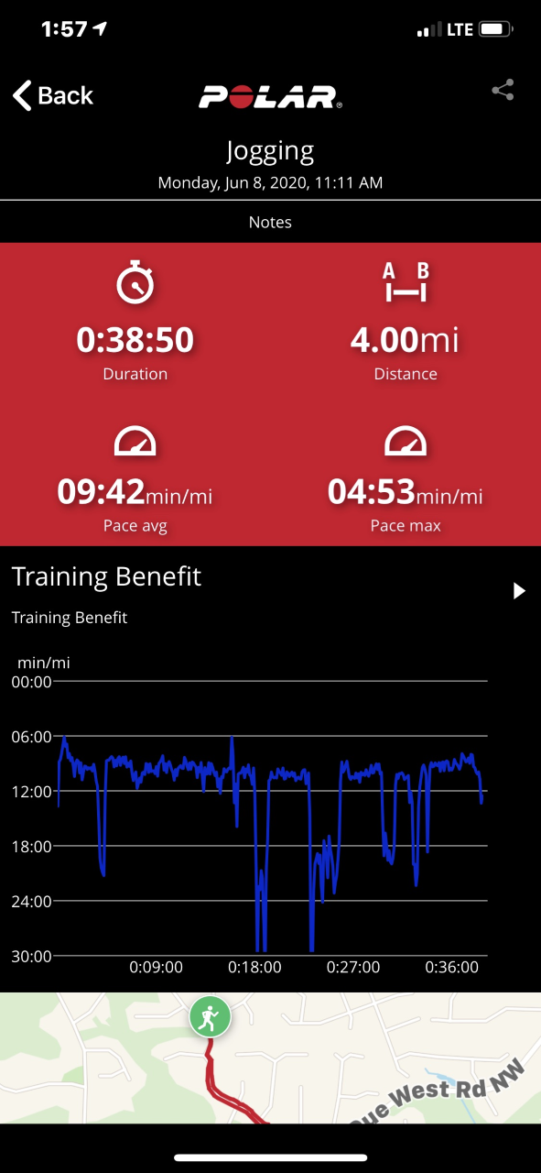

If you have any questions, please feel free to contact me at: deanna.stewart@cobbk12.org

Sincerely,

Deanna Stewart

