Course Description:
HEALTH: Students in high school demonstrate comprehensive health knowledge and skills. Their behaviors reflect a conceptual understanding of the issues associated with maintaining good personal health. They serve the community through the practice of health-enhancing behaviors that promote wellness throughout life.
Health Concepts
Health Choices, Decision Making Skills, Goal Setting, Time Management, Mental and Emotional Health, Your Personality, Stress Management, Emotional Problems, Tobacco, Drug Abuse, Alcohol, Infectious Diseases, AIDS, STD’s, Cancer, Heart and Artery Disease, Pairing Commitment and Marriage, Conception and Parenting, Alcohol and Drug Awareness Program (ADAP) as required by the state of Georgia, and CPR.

PERSONAL FITNESS: Introduces instruction in methods to attain a healthy level of physical fitness; implements a lifetime fitness program based on a personal fitness assessment and stresses strength, muscular endurance, flexibility, body composition, and cardiovascular endurance; includes instruction in fitness principles, nutrition, fad diets, weight control, stress management, adherence strategies, and consumer information; and promotes self-awareness and responsibility for fitness.
This course meets the state requirements and is required for graduation.
Textbook and Materials:
Textbook:
- Foundations of Personal Fitness
- Glencoe Health
Materials:
- 1 ½” Three Ring Binder
- Blue/Black pens only
- #2 pencils
- Exercise clothing
- Combination lock (face to face only)

*Students are required to bring their notebook, paper, books and writing utensils to class.
*Students should have exercise clothing on workout days.

Standards

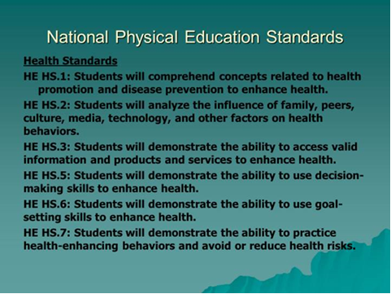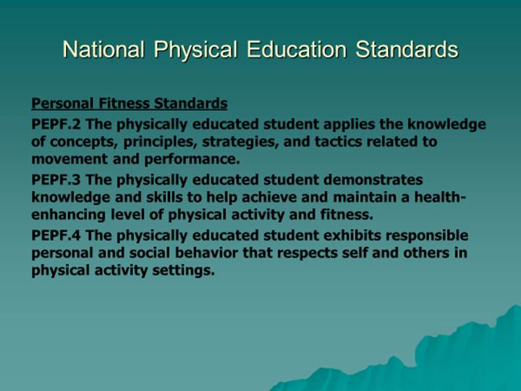

Evaluation:
Participation 30%
*including weekly post workout reflections
Test/Quizzes 35%
Projects/Assignments 20%
*including participating in discussion boards
Final Exam 20%
NOTE: ACADEMIC DISHONESTY WILL RESULT IN A GRADE OF ZERO FOR THE ASSIGNMENT, A MARK OF UNSATISFACTORY IN CONDUCT, AND PARENT CONTACT.
CLASSROOM RULES
- Be logged CTLS at the start of your class period. Message through Remind immediately if you have technical difficulties.
- Harrison High School Tardy Policy – TBA
- You must be prepared for class at the beginning of the class period
(pencil, pen, notebook, workout clothes, etc.)
- MAKE-UP WORK:
- It is YOUR RESPONSIBILITY to check my blog/CTLS to make up missed assignments

Workout Days: Tuesdays & Fridays
You are expected to be dressed at the beginning of your class period.
Workout clothes - Dress comfortably:
  - T-shirt (dryfit) and “exercise” shorts
  - Socks
  - Running shoes only
Participation/Workout Make-Up Policies
- Each student receives 100 points/week for dressing out and participating. (30% of your overall grade)
- All absences on workout days must be made up to earn back points.
- Make up sessions are held every Wednesday.
  - All workouts will be posted, so check CTLS for missed workouts.
- Students who are injured for an extended period of time, must make up workout days by completing a paper that will be assigned to you as it pertains to you specific injury.
  - You MUST have a doctor’s note listing your restrictions and how long you will be unable to participate.
- Depending on the type of injury, the teacher will be to adapt workouts to meet the workout day requirements.

Typical Workout Day
- Attendance through CTLS
- Warm-up (10 minutes)
- Workout (teacher driven – approximately 30-40 minutes)
- Class discussion through CTLS (10 minutes)
- Complete Workout Reflection Form

