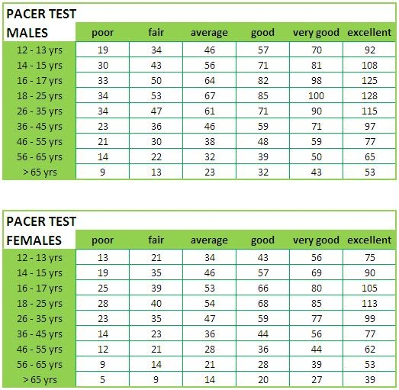
What was your score on the pacer test?
Beginning ___________
Now ___________
Goal for the future _________
Using the chart below, explain how will you overload to achieve this? (FITT)
Think about how the pacer is completed. Run faster as you run longer.

CARDIO | FREQUENCY | INTENSITY | TIME | TYPE

Coopers Test – 12 minute run - Male Athletes
Age | Excellent | Above Average | Average | Below Average | Poor
13-14 | >2700m | 2400-2700m | 2200-2399m | 2100-2199m | <2100m
15-16 | >2800m | 2500-2800m | 2300-2499m | 2200-2299m | <2200m
17-19 | >3000m | 2700-3000m | 2500-2699m | 2300-2499m | <2300m
20-29 | >2800m | 2400-2800m | 2200-2399m | 1600-2199m | <1600m
30-39 | >2700m | 2300-2700m | 1900-2299m | 1500-1999m | <1500m
40-49 | >2500m | 2100-2500m | 1700-2099m | 1400-1699m | <1400m
>50 | >2400m | 2000-2400m | 1600-1999m | 1300-1599m | <1300m

Female Athletes
Age | Excellent | Above Average | Average | Below Average | Poor
13-14 | >2000m | 1900-2000m | 1600-1899m | 1500-1599m | <1500m
15-16 | >2100m | 2000-2100m | 1700-1999m | 1600-1699m | <1600m
17-20 | >2300m | 2100-2300m | 1800-2099m | 1700-1799m | <1700m
20-29 | >2700m | 2200-2700m | 1800-2199m | 1500-1799m | <1500m
30-39 | >2500m | 2000-2500m | 1700-1999m | 1400-1699m | <1400m
40-49 | >2300m | 1900-2300m | 1500-1899m | 1200-1499m | <1200m
>50 | >2200m | 1700-2200m | 1400-1699m | 1100-1399m | <1100m

What was your score on the Cooper’s Test (12 minute run)? To calculate: 1 lap is 400 meters. How many meters did you run in 12 min.?
Using the chart below, explain how you will overload. Think about how the Cooper’s Test is different than the Pacer Test
Beginning ___________
Now ___________
Goal for the future _________
CARDIO | FREQUENCY | INTENSITY | TIME | TYPE
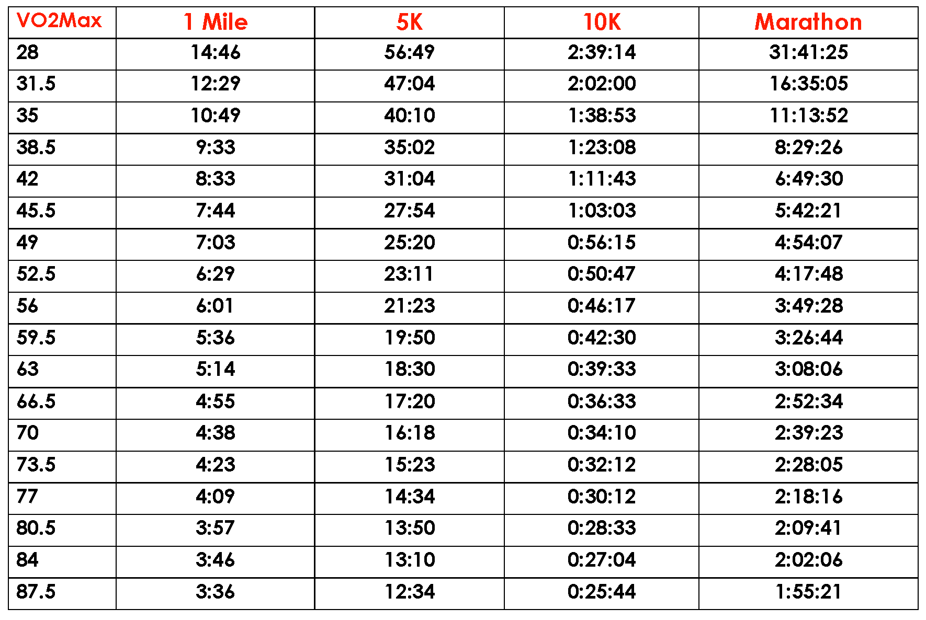
Mile Time ____________
VO2 Max ____________
Mile Time Goal _____________
VO2 Max Goal ____________
You will have to run ____________ to improve your VO2 Max. How can you train to achieve your goal?
Frequency

Intensity
Time
Type

