Monday Reminders 8/31/20
- Blog –
  - Week at a Glance
  - Assignments to be found in case CTLS does not work
- Health Chapter 1 & 2 Test – Quizizz Code 28468608
Must be completed by 3:00pm today
- I will enter all grades today in ParentVue/StudentVue
  - Please check to see if you have any zeros – you will have through next Monday to get caught up with any work that you have missed/not completed.
- This week we will be working in our Personal Fitness – Chapter 3
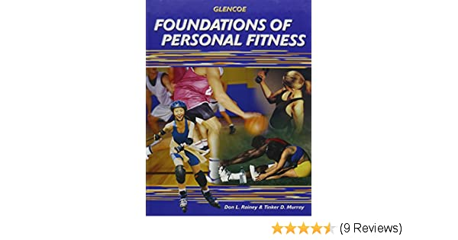

  - Chapter 3 – we will be applying the Training Principles
    - Overload (FITT)
    - Specificity
    - Progression
  - You have one assignment – applying the Training Principles – Due Friday
  - Vocabulary Quiz on Thursday on Quizizz – 80% or better on the Quiz and you will earn 5 points bonus on your Chapter 3 Test.
  - Personal Fitness Chapter 3 Test – beginning on Thursday
- Reminder – Next Monday – No Class (Labor Day)
  - During that week – we will have class on Tuesday
  - You will need to complete one workout on your own & submit your Workout Reflection

